A GALLERY OF GODS
Horned, maned, hawk-faced and crocodile-headed gods all marched side by side in Egypt’s grand parade of deities.

The Egyptians worshipped a multitude of gods. Many were local deities at first, but were absorbed into a system of belief that permitted overlapping roles. The priests evolved a creation myth and a family tree to explain how some of the main gods and goddesses were related. In the limitless darkness there existed a primeval ocean called Nun, out of which rose the sun god Re, a supreme being who spat out the elements of air and moisture. They in turn gave birth to the earth god, Geb, and the sky goddess Nut. And out of their union came four children: Osiris, Isis, Seth and Nephthys. Some of the main gods and their attributes were;

Re: The sun god and lord of creation. From his centre of worship at Heliopolis he rose to become a national deity. By day Re traversed the sky in his sun boat; at night he disappeared into the underworld. Worshippers hoped for reunion with Re in the afterlife. He was pictured with a falcon’s head (like Horus) and a sun disc.
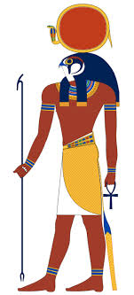

Amun: Originally a fertility god worshipped in Thebes. Amun became one of Egypt’s national deities. As a sky god, he fused with Re and became Amun-Re the king of the gods.
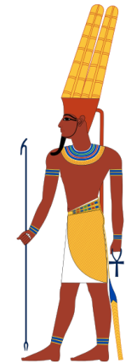

Osiris: The god of death and rebirth, associated with the growth and decay of vegetation. In winter he was thought to disappear with the crops into the underworld and he had a special role as god of the dead.
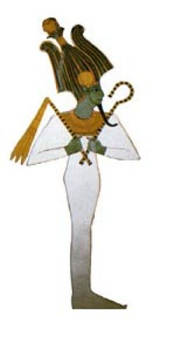

Isis: The sister and wife of Osiris. In mythology she reconstructed Osiris after his murder by his brother Seth. Ordinary folk worshipped Isis as a maternal and protective goddess with many healing powers. She was often represented holding the infant Horus, and sometimes shown (like Hathor) with cow’s horns.
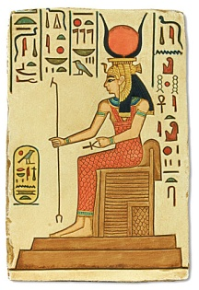

Nephthys: The sister and bosom companion of Isis. Nephthys was the wife of the evil Seth, but when this malign god murdered Osiris her sympathies lay with the heart broken Isis.
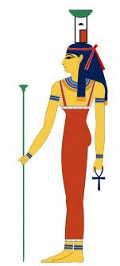

Seth: the brother and murderer of Osiris. A sky god in origin, Seth was said to have killed his brother and so came to represent evil and chaotic forces. Offerings were made to him nonetheless for he was lord of the red land or desert, and the ruler of droughts and storms.

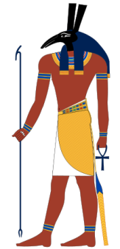

Horus: The son of Osiris and Isis, he was portrayed as a falcon god. Believing themselves to be offspring of the gods, the pharaohs saw themselves as living incarnations of Horus and capable of soaring with him to the sun. People wore Eye of Horus amulets to ward off the evil eye.

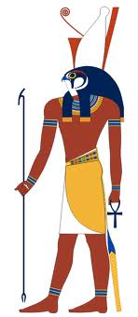

Hathor: The goddess of love, happiness, music and – inebriation. Portrayed as a cow or with a headgear of cow’s horns, this popular deity embodied female sexuality and fertility. Hathor was the patron of dancing girls and was invoked by women during childbirth.
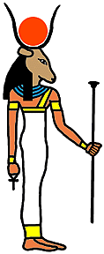

Anubis: The jackal - headed god of embalming, who admitted the dead to the underworld. Priests officiating at the Opening of the Mouth ceremony wore a jackal-headed Anubis mask. According to one account, Anubis was the offspring of the gods, Nephthys and Osiris.
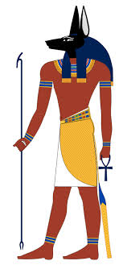

Thoth: The god of learning, Thoth kept the god’s records and was credited with the invention of writing and mathematics. Thoth was the patron of scribes, and his major cult centre was at Khmunu.
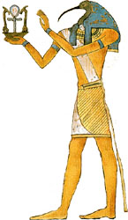

Ptah: The local god of Memphis, and among the most ancient and prominent of Egypt’s deities. He was named supreme god at the time when Egypt was first unified and was credited by his priest with the world’s creation. In later times he was known as the god of craftsmen.
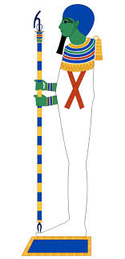

Khnum: The ram-headed god of the cataract region of the Nile, Khnum was said to have control of the river’s annual floods. The ram symbolised procreativity, and the priests in Khnum’s temple at Esnu taught that the god was humankind’s creator.
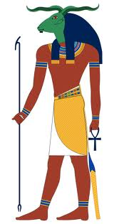

Sobek: The crocodile-headed solar god. His centre of worship was at the oasis city of Shedet (also known as Crocodilopolis) in the Faiyum district of northern Egypt, where there were water reservoirs vital to the whole country. Fishermen made offerings to Sobek to propitiate the fearsome reptile god.
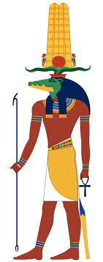

Sakhmet: The lioness goddess whose name meant “The Powerful One”. She was a ferocious war goddess employed by the vengeful sun god against the human race. She also caused – and cured – epidemics.

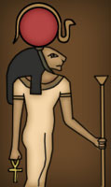

THREE SPELLS:
The Egyptians anticipated meeting all kinds of perils in the afterlife and took various measures to guard against them. They placed objects such as scarabs in the wrappings of mummies and cast spells for protection. The three spells that follow are taken from the Book of the Dead.
Spell for driving off a snake:
o Rerek-snake, take yourself off, for Geb protects me; get up, for you have eaten a mouse, which Re detests, and you have chewed the bones of a putrid cat.

Spell for repelling a beetle:
Begone from me, O Crooked-lips, I am Khnum, Lord of Peshu, who despatches the words of the gods to Re, and I report affairs to their master.

Spell for not putrefying in the realm of the dead:
Weary, weary are the members of Osiris! They shall not be weary, they shall not putrefy, they shall not decay, and they shall not swell up! May it be done to me in like manner, for I am Osiris.

Reference: Mind, Body and Spirit: A Gallery of Gods pgs 126-128

